Q1:
import java.util.List;
public class Q1 {
public static double calculateAverage(List<String> integerList) {
int sum = 0;
int count = 0;
for (String str : integerList) {
try {
int num = Integer.parseInt(str);
sum += num;
count++;
} catch (NumberFormatException e) {
System.out.println("Non-numeric data skipped");
}
}
if (count == 0) {
throw new IllegalArgumentException("List contains only invalid integers.");
}
return (double) sum / count;
}
public static void main(String[] args) {
List<String> integerList = List.of("four","","three");
try {
double average = calculateAverage(integerList);
System.out.println("The average is: " + average);
} catch (IllegalArgumentException e) {
System.out.println(e.getMessage());
} catch (NullPointerException e) {
System.out.println("List is null or empty.");
}
}
}

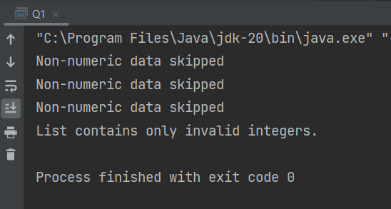
Q2:
import java.math.BigInteger;
import java.util.Scanner;
public class FactorialCalculator {
public static BigInteger calculateFactorial(int n) {
BigInteger result = BigInteger.valueOf(1);
for (int i = 2; i <= n; i++) {
result = result.multiply(BigInteger.valueOf(i));
}
return result;
}
public static void main(String[] args) {
Scanner scanner = new Scanner(System.in);
System.out.print("Enter an integer to calculate its factorial: ");
String input = scanner.nextLine();
try {
if (input == null || input.isEmpty()) {
throw new IllegalArgumentException("Input string cannot be null or empty.");
}
int n = Integer.parseInt(input);
if (n < 0) {
throw new IllegalArgumentException("Input integer cannot be negative.");
}
BigInteger factorial = calculateFactorial(n);
System.out.println(n + "! = " + factorial);
} catch (NumberFormatException e) {
System.out.println("Input string is not a valid integer.");
} catch (IllegalArgumentException e) {
System.out.println(e.getMessage());
} catch (ArithmeticException e) {
System.out.println("Input integer is too large to calculate the factorial.");
}
}
}

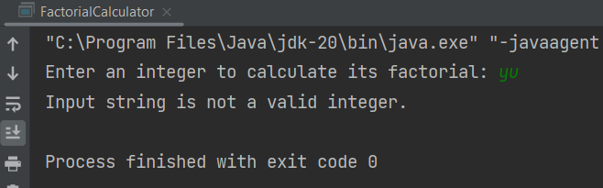
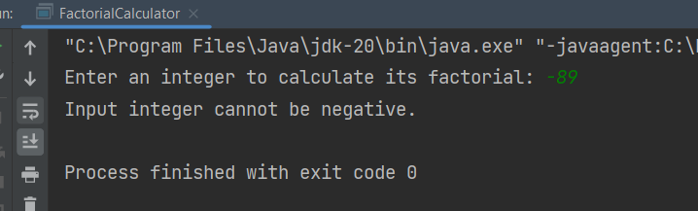
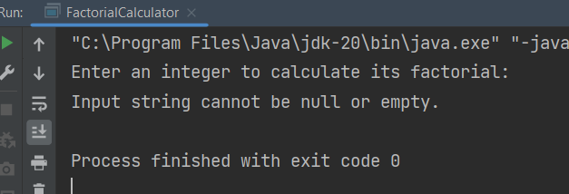
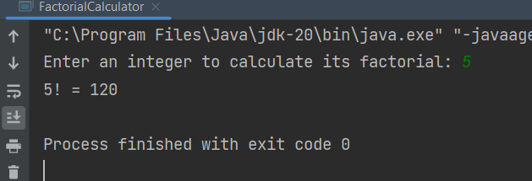
Q3:
import java.util.Scanner;
public class Q3 {
public static void main(String[] args) {
Scanner scanner = new Scanner(System.in);
System.out.print("Enter the first number: ");
String input1 = scanner.nextLine();
System.out.print("Enter the second number: ");
String input2 = scanner.nextLine();
try {
if (input1 == null || input1.isEmpty() || input2 == null || input2.isEmpty()) {
throw new IllegalArgumentException("string cannot be null or empty.");
}
double num1 = Double.parseDouble(input1);
double num2 = Double.parseDouble(input2);
double result = 0;
System.out.print("Enter the mathematical operator (+, -, *, /): ");
String operator = scanner.nextLine();
switch (operator) {
case "+":
result = num1 + num2;
break;
case "-":
result = num1 - num2;
break;
case "*":
result = num1 * num2;
break;
case "/":
if (num2 == 0) {
throw new ArithmeticException("Cannot divide by zero.");
}
result = num1 / num2;
break;
default:
throw new IllegalArgumentException("Invalid operator.");
}
System.out.println("Result: " + result);
} catch (NumberFormatException e) {
System.out.println("Input string(s) are not valid numbers.");
} catch (IllegalArgumentException | ArithmeticException e) {
System.out.println(e.getMessage());
}
}
}
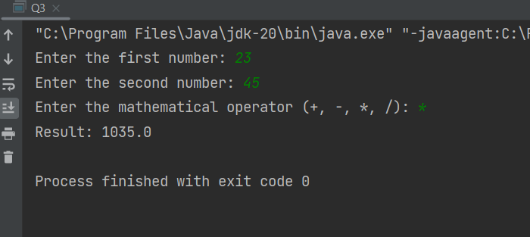
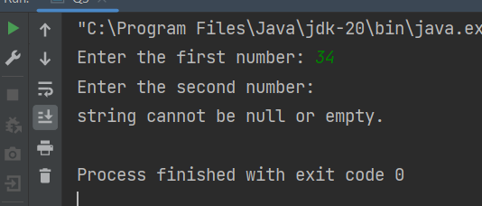
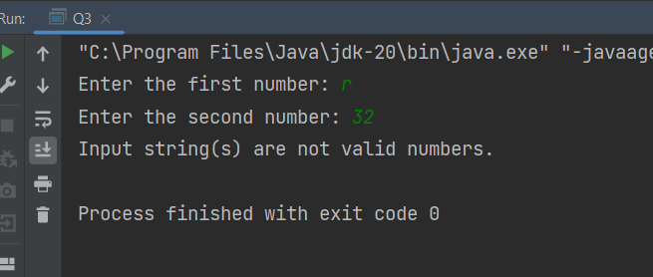
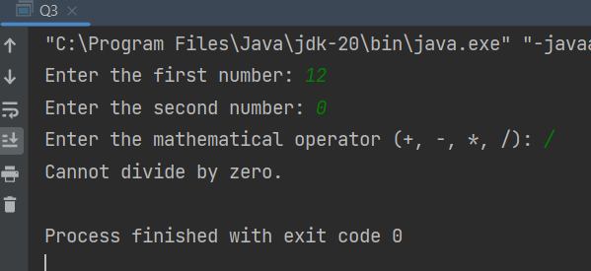
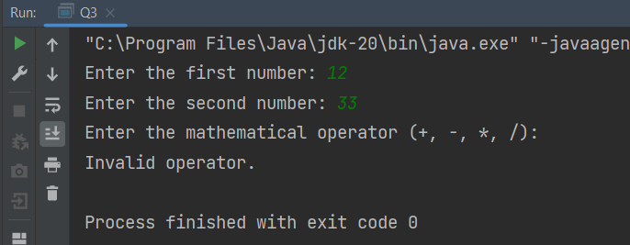
Q4:
import java.util.Scanner;
public class Q4 {
public static void main(String[] args) {
Scanner scanner = new Scanner(System.in);
System.out.print("Enter a sentence (at least two words): ");
String sentence = scanner.nextLine();
try {
if (sentence == null || sentence.isEmpty()) {
throw new IllegalArgumentException("Input string cannot be null or empty.");
}
String[] words = sentence.split(" ");
if (words.length < 2) {
throw new IllegalArgumentException("Input string must contain at least two words.");
}
// Perform operations on the sentence
String firstWord = words[0];
String lastWord = words[words.length - 1];
String modifiedSentence = sentence.replace(" ", "");
System.out.println("First word: " + firstWord);
System.out.println("Last word: " + lastWord);
System.out.println("Modified sentence: " + modifiedSentence);
} catch (IllegalArgumentException e) {
System.out.println(e.getMessage());
}
}
}
